**EXPERIMENT 1**

AIM: Define a class product with data members pcode, pname and price.Create 3 objects of the class and find the product having the lowest price.

**ALGORITHM**

**PROGRAM**

**import** java.util.Scanner;

**class** product

{

**int** pcode;

String pname;

**float** pcost;

**void** getdata()

{

Scanner s=**new** Scanner(System.***in***);

System.***out***.print("enter pcode\t");

pcode=s.nextInt();

System.***out***.print("enter pname\t");

pname=s.next();

System.***out***.print("enter pcost\t");

pcost=s.nextFloat();

}

**void** display()

{

System.***out***.println(pcode+":"+pname+"."+pcost);

}

}

**class** productprice

{

**public** **static** **void** main (String args[])

{

product p1=**new** product();

p1.getdata();

product p2=**new** product();

p2.getdata();

product p3=**new** product();

p3.getdata();

p1.display();

p2.display();

p3.display();

**if**(p1.pcost<p2.pcost&&p1.pcost<p3.pcost)

{

System.***out***.println(p1.pname+"has lowest cost");

}

**else** **if**(p2.pcost<p3.pcost)

{

System.***out***.println(p2.pname+" has lowest cost");

}

**else**

{

System.***out***.println(p3.pname+" has lowest cost");

}

}

}

**OUTPUT**

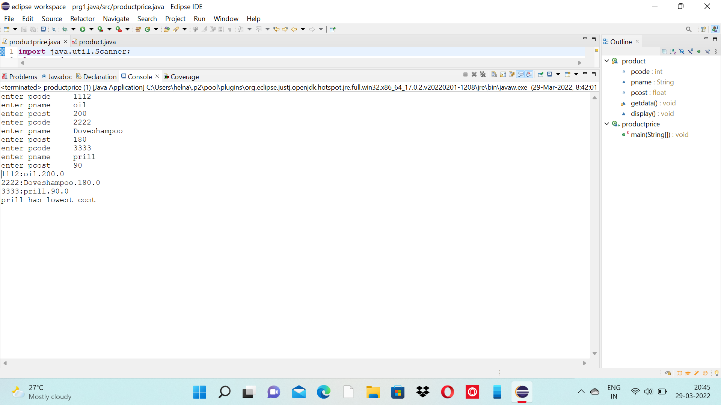

**EXPERIMENT 2**

AIM:Read 2 matrices from the console and perform matrix addition.

**ALGORITHM**

**PROGRAM**

package array; import java.util.Scanner;

public class matrixadd

{

public static void main(String args[])

{

int i,j,m,n;

Scanner input=new Scanner(System.in); System.out.println("Enter row and coloumn size"); m=input.nextInt(); n=input.nextInt(); int a[][]=new int[m][n]; int b[][]=new int[m][n]; int c[][]=new int[m][n];

System.out.println("Enter the first matrix");

for(i=0;i<m;i++)

{ for(j=0;j<n;j++)

{

a[i][j]=input.nextInt();

}

}

System.out.println("Enter the second matrix"); for(i=0;i<m;i++)

{ for(j=0;j<n;j++)

{

b[i][j]=input.nextInt();

}

}

System.out.println("first matrix");

{

for(i=0;i<m;i++) {

for(j=0;j<n;j++)

{

System.out.print(a[i][j]+"\t");

}

System.out.println();

}

}

System.out.println("second matrix");

{ for(i=0;i<m;i++) {

for(j=0;j<n;j++)

{

System.out.print(b[i][j]+"\t");

}

System.out.println();

}

}

System.out.println("SUM OF 2 MATRIX IS");

for(i=0;i<m;i++)

{ for(j=0;j<n;j++)

{

c[i][j]=a[i][j]+b[i][j]; System.out.print(c[i][j]+"\t");

}

System.out.println();

}

}

}

**OUTPUT**

